Functions in c++
A function is a group of statements that together perform a task. Every C++ program has at least one function, which is main(), and all the most trivial programs can define additional functions.
Types Of Functions In C++

In C++, we have two types of function Those are
- Built- in- functions
- User defined functions

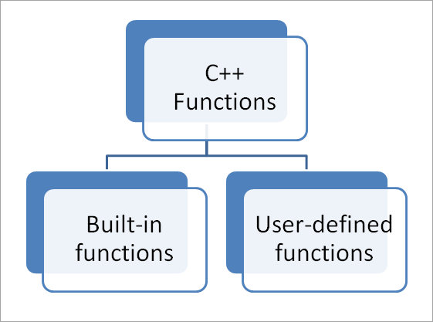

User defined functions

Elements of Functions
- Every function has the following elements:
- Function Declaration (Function Prototype)
- Function Definition
- Function Call

Function Declaration (Function prototype)
- Similar to variables, in C++, every function needs to be declared before it can be used.
- Functions can be declared either globally (inside the main() ) or locally (outside the main() ) as per the program requirementSyntax:

Syntax:
return_type function_name ( argument list ) ;
- Function prototype has the following three parts:

Return type :
- It specifies return type of the function that means type of the data that a function will return such as int, float, char etc.
- Function that does not return any value will have return type as void.

Function Name:
- It is the name of the function and it should be any meaningful name.
- It should follow all naming convention rules.
- Some examples of function names are display, show, calculate etc.

Argument List:
- Argument list specifies list of all arguments required for the function to perform the desired task.
- Arguments are separated by comma. It may include both data type and argument name but normally only data type is provided.
- The following is an example of function prototype for doing sum of two float values:

Function Declaration Example
float sum ( float, float ) ; OR float sum (float x, float y) ;
- Where, int is a return type, sum is the name of the function and int x, int y are the argument list.

Function Definition
- Function definition contains executable block of statements.
- It can be written either before or after the main() but normally it is written after the main().
Syntax:
return_type function_name( argument list )
{
// local variable declaration ;

// executable statements ;

:
:

// return statement ;
}
- The function definition contains the following two parts:
- Function Header
- Function Body

Function Header:
- The first line of function definition is known as function header.
- It consists of three parts: return type, function name and argument list.

Function Body:
- It consists of three parts: local variable declaration part, executable part and return statement.
- All the required variables are declared at the local variable declaration part.
- Executable part contains all the executable statements that performs actual task.
- return statement should be the last statement inside the function body. It is optional.
- If return type of function is void then it can be omitted but function having return type other than void must include return statement.
- Example of function definition is given below for above function declaration.

Function Definition Example
float sum ( float x, float y)
{
float result ; // local variable
result = x + y ; // executable statement

return result ; // return statement
}
- Example of function without return type is as follow:
void sum ( float x, float y)
{
float result ; // local variable
result = x + y ; // executable statement
cout<< “ Sum is” << result;
return ; // return statement. its optional
}
- Note : We can omit return statement if function return type is void.

Function Call
- A function can be called simply by using name of the function followed by a list of Actual parameters (Arguments) if any.
- The following example calls sum() function that we defined above.
void main ( )
{
float result ; // receiver local variable
result = sum (10.0, 20.0 ); // function call
printf(“\n Sum is %.2f” , result);

}
- When the compiler encounters a function call, the control is transferred to the function definition and executes the function line by line and a computed value is returned with the help of return statement.
- The returned value is assigned to the receiver variable. This is illustrated as below:
- Arguments that passed in function call and arguments receiving in function definition should have the same data type.
- For example in above function call sum (10.0, 20.0) we have passed arguments of float type and inside function definition those float type arguments are received by float type variable x and y respectively. In short, type of arguments in function call and function definition should be same.
- The argument names used in function definition is known as formal parameters.

What are local variables and global variables in C++?

A scope is a region of the program and broadly speaking there are three places, where variables can be declared −
- Inside a function or a block which is called local variables,
- In the definition of function parameters which is called formal parameters.
- Outside of all functions which are called global variables.

Local variables can be used only by statements that are inside that function or block of code. Local variables are not known to functions on their own.

Example
#include <iostream>
using namespace std;
int main () {
// Local variable declaration:
int a, b;
int c;
a = 10;
b = 20;
c = a + b;

cout << c;
return 0;
}

Output
This will give the output −
30
Global variables are defined outside of all the functions, usually on top of the program. The global variables will hold their value throughout the lifetime of your program. A global variable can be accessed by any function.

Example
#include <iostream>
using namespace std;
// Global variable declaration:
int g;
int main () {
// Local variable declaration:
int a, b;
a = 10;
b = 20;
g = a + b;

cout << g;
return 0;
}

Output
This will give the output −
30

Recursion
Recursion is the technique of making a function call itself. This technique provides a way to break complicated problems down into simple problems which are easier to solve.

Working of Recursion in C++

voidrecurse()
{
... .. ...
recurse();
... .. ...
}

intmain()
{
... .. ...
recurse();
... .. ...
}
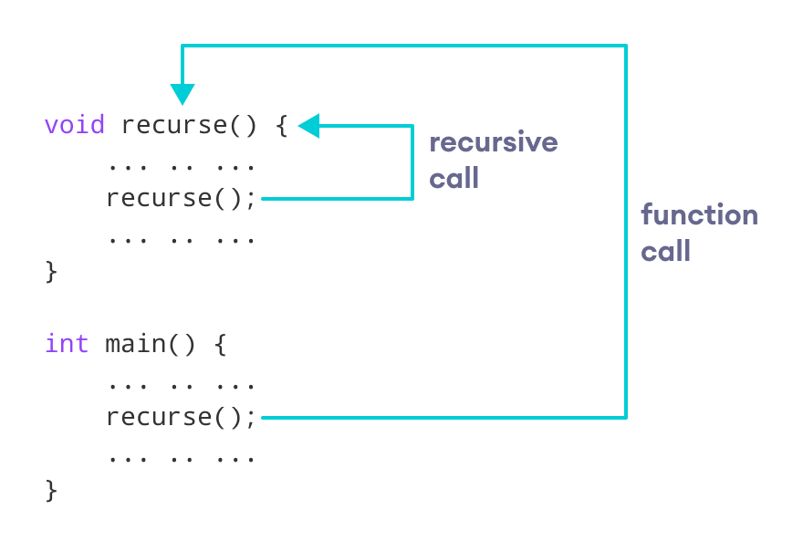

#include <iostream>

intfactorial(int);

intmain() {
int n, result;

cout<<"Enter a non-negative number: ";
cin>> n;

result = factorial(n);
cout<<"Factorial of "<< n <<" = "<< result;
return0;
}

intfactorial(int n) {
if (n >1) {
return n * factorial(n - 1);
} else {
return1;
}
}

BUILT IN FUNCTION OR LIBRARY FUNCTIONS:
  - Library functions are pre-defined functions.
  - Library functions are part of header file.
  - In Library function, name of function cannot be changed
  - List various MATH LIBRARY FUNCTION:
  - These functions are used to perform mathematical calculations in a program.
  - There are various functions as follows:
Function name | Purpose | Example
sqrt(x) | square root of ‘x’ | sqrt(4)=2
sin(x) | trigonometric sine of ‘x’ | sin(30)=0.5
cos(x) | trigonometric cosine of  ‘x’ | cos(60)=0.5
tan(x) | trigonometric tangent of  ‘x’ | tan(45)=1
exp(x) | exponential function of  ‘x’ | exp(2)=e^2
pow(x,y) | x raised to power y | pow(2,3)=2^3=8
log(x) | logarithmic function of  x(natural i.e; base ‘e’) | log(2)=0.3010
log10(x) | logarithmic function of  x(base 10) | log10(10)=1
ceil(x) | rounds x to the smallest  integer not less than x | ceil(8.1)=9.0  ceil(-8.8)=-8
floor(x) | rounds x to the largest  integer not greater than x | floor(8.2)=8.0  floor(-8.8)=-9.0

abs(x) | absolute value of x,if (i)if,x>0,then abs(x)=x (ii)if,x=0,then abs(x)=0  (iii)if,x<0,then abs(x)=-x | abs(10)=10 abs(0)=0  abs(-10)=-(-10)=10

PROGRAM:
#include<iostream.h> Void main()
{
Cout<<”the built in functions are”<<endl; Cout<<sqrt(4)<<endl; Cout<<sin(30)<<endl; Cout<<cos(60)<<endl; Cout<<tan(45)<<endl; Cout<<exp(2)<<endl; Cout<<pow(2,3)<<endl; Cout<<log(2)<<endl; Cout<<log(10)<<endl; Cout<<ceil(8.1)<<endl; Cout<<floor(8.2)<<endl; Cout<<abs(10)<<endl;
}

C++ OOPs Concepts

The major purpose of C++ programming is to introduce the concept of object orientation to the C programming language.
Object Oriented Programming is a paradigm that provides many concepts such as inheritance, data binding, polymorphism etc.
The programming paradigm where everything is represented as an object is known as truly object-oriented programming language. Smalltalk is considered as the first truly object-oriented programming language.
Feature of OOPS
- Emphasis on data rather procedure.
- Programs are divided into units called “Objects”.
- Objects used to communicate with each other through functions.
- New functionality can be easily developed by creating objects and functions.

OOPs (Object Oriented Programming System)
Object means a real word entity such as pen, chair, table etc. Object-Oriented Programming is a methodology or paradigm to design a program using classes and objects. It simplifies the software development and maintenance by providing some concepts:

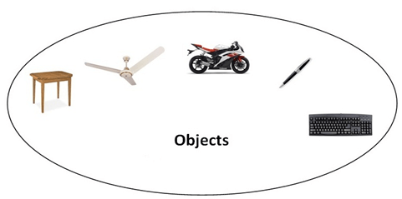
- Object
- Class
- Inheritance
- Polymorphism
- Abstraction
- Encapsulation
Object
Any entity that has state and behavior is known as an object. For example: chair, pen, table, keyboard, bike etc. It can be physical and logical.
Class
Collection of objects is called class. It is a logical entity.
Inheritance
When one object acquires all the properties and behaviours of parent object i.e. known as inheritance. It provides code reusability. It is used to achieve runtime polymorphism.
Polymorphism
When one task is performed by different ways i.e. known as polymorphism. For example: to convince the customer differently, to draw something e.g. shape or rectangle etc.
In C++, we use Function overloading and Function overriding to achieve polymorphism.
Abstraction
Hiding internal details and showing functionality is known as abstraction. For example: phone call, we don't know the internal processing.
In C++, we use abstract class and interface to achieve abstraction.
Encapsulation
Binding (or wrapping) code and data together into a single unit is known as encapsulation. For example: capsule, it is wrapped with different medicines.

Advantage of OOPs over Procedure-oriented programming language
- OOPs makes development and maintenance easier where as in Procedure-oriented programming language it is not easy to manage if code grows as project size grows.
- OOPs provide data hiding whereas in Procedure-oriented programming language a global data can be accessed from anywhere.
- OOPs provide ability to simulate real-world event much more effectively. We can provide the solution of real word problem if we are using the Object-Oriented Programming language.
Define a class. Explain about class specification.
Definition:
- A class is a collection of data members and member functions.
- A class is a way to bind the data and its associated functions together.
- C++ allows the data and functions into a single unit is called a class..
- When defining a class, we are creating a new ABSTRACT DATA TYPE that can be treated like any other built-in data type.
Class Specification:
- Generally a class specification has two parts:
- Class declaration
- Class function definition.
- Class declaration: (How to declare or create a class?) Class is a collection of data members and member functions. Declaration of a class:
Syntax:
class classname
{
Private:
Data members;
Member functions;
Public:
Data members;
Member functions;
};
Explanation:
- The keyword class is used to declare a class followed by class name.
- The body of a class is enclosed within braces and terminated by a semicolon.
- The class body contains the declaration of variables (data members) and functions (member functions).
- These functions and variables are collectively called MEMEBRS.
- The variables declared inside the class are known as data members and the functions are known as member functions.
- They are usually grouped under two sections, PRIVATE and PUBLIC to denote which of the members are private and which of the members are public.
- The keywords PRIVATE and PUBLIC are known as Access specifiers.
- The members that have been declared as PRIVATE can be accessed only from within the class. i.e, PUBLIC members can be accessed from outside the class also.
- The use of PRIVATE is optional. By default, the members of a class are PRIVATE.
Example:

class Employee
{
Private:
int eid; float salary;
Public:
void getdata(int a, float b); void putdata();
};

Access specifiers

Data hiding is one of the important features of Object Oriented Programming which allows preventing the functions of a program to access directly the internal representation of a class type. The access restriction to the class members is specified by the labeled public, private, and protected sections within the class body. The keywords public, private, and protected are called access specifiers.
A class can have multiple public, protected, or private labeled sections. Each section remains in effect until either another section label or the closing right brace of the class body is seen.

The default access for members and classes is private.

class Base {
public:
// public members go here
protected:

// protected members go here
private:
// private members go here

};

The public Members
A public member is accessible from anywhere outside the class but within a program
class Box

{

public:
double length;
void setWidth( double wid );
double getWidth( void );
};

The private Members
A private member variable or function cannot be accessed, or even viewed from outside the class. Only the class and friend functions can access private members.
class Box {
double width;

public:
double length;
void setWidth( double wid );
double getWidth( void );
};

The protected Members
A protected member variable or function is very similar to a private member but it provided one additional benefit that they can be accessed in child classes which are called derived classes.
#include<iostream>usingnamespace std;
classBox{
protected:
double width;};

Creating Objects or object creation
How to create an object?
- Objects are instances of classes.
- Once a class has been declared, we can create variables of that type by using the class name.
- We have two methods to create objects to a class
Method 1:
- We will create the objects in main() as follows:
- Syntax:
classname objectname;
- Example:
Employee e1;
- In the above example e1 is an object of a class Employee.
- We can create multiple objects at a time to a class;
- Syntax:
classname objectname1, objectname2, Objectnamen;
- Example:
Employee e1,e2,e3;

Method2:

- We can create the objects at time of class declaration itself
- That is, Objects can also be created when a class is declared by placing their names immediately after the closing brace as follows.
- Syntax:
class classname
{
Datamembers;
Member functions;
} objectnam1,objectname2,……objectnamen;
- Example:
Class Employee
{
int eid; float salary;
} e1,e2,e3;
- In the above example we created 3 objects e1,e2,e3 to a class Employee at the time declaration of class.
Defining Member functions (How to define member function?)
- Class contains data members and member functions.
- We will declare member functions inside the class.
- Whereas we will define member functions either inside the class or outside the class
- That is, member functions can be defined in two places:
  - Outside the class
  - Inside the class
- Outside the Class:
  - Member functions that are declared inside a class have to be defined separately outside the class.
  - To define the function outside the class we will use class name followed by :: (scope resolution operator) followed by function name,
  - Syntax:
Return-type class-name :: function-name (Parameters List)
{
//Function body
}
The membership label classname :: tell the compiler that the function function- name belongs to the class classname. That means, The specified function belongs to specified class.
- Example:
void Employee :: getdata(int a, float b)
{
eid = a; salary = b;
}
- Here in the above example getdata() function belongs to class Employee.
Inside the class:
- Another method of defining a member function is to replace the function declaration by the actual function definition inside the class.
- Example:
class Employee
{
int eid; float salary;
Public:
void getdata(int a, float b)
(
eid=a;
salary=b;
}
void putdata()
{
cout<<eid<<endl; cout<<salary<<endl;
};
- In the above example both functions getdata() and putdata() both are defined inside the class only.
- NOTE: When the function is defined inside a class , it is treated as an inline function.

Accessing member functions (How to access member functions)

- We can access member functions of a class using objects followed by ‘.’ Operator (member accessing operator) followed by function name.
- In the main() we will call access member functions.
- Syntax:
object name . function-name (arguments);
- Example:
e1.getdata(10,20000.00);
- In the above example we are calling getdata() function using an object e1 with two arguments 10 and 20000.00.
Constructors
What is mean by constructor? Explain types of constructors.
- C++ provides a special member function called the CONSTRUCTOR which enables an object to initialize itself when it is created. This is known as automatic initialization of objects.
- A constructor is a ‘special’ member function whose task is to initialize the objects of its class.
- It is special because constructor name is the same as the class name.
- The constructor is invoked whenever an object of its associated class is created.
- It is called constructor because it construct the values of data members of the class.
- There are 3 different types constructors
- Default constructor
- Parameterized constructor
- Copy constructor
- Default constructor:
  - A constructor which does not take arguments or parameters is called default constructor.
  - A constructor that accepts no parameters is called DEFAULT CONSTRUCTOR.
  - Default constructor name and class name must be same.
  - Syntax to create default constructor:
classname()
{
//constructor definition or constructor body
}
Example:
item()
{ m=0; n=0;
}
- In the above example, constructor declaration and definition done at a time.
- We can declare and define a constructor separately like functions.
- Declaration we will do inside the class and constructor definition outside the class as follows.
- Example:

class item
{
int m,n; public:
item(); //constructor declaration
};
item :: item () // constructor definition
{ m=0; n=0;
}
In the example the declaration not only creates the object of type class item but also initialized its data member’s m and n to zero. There is no need to write any statement to invoke(call) the constructor function. If a normal member function is defined for zero initialization, we would need to invoke this function for each of the objects separately.
Program (Default Constructor):

#include<iostream.h> class cube
{
public:
int side;
cube() //Default Constructor
{
side=10;
}
};
void main()
{
cube c1; cout<<c1.side;
}
Parameterized Constructor:
- The constructors that can take arguments are called PARAMETERIZED CONSTRUCTORS.
- Constructor name and class name must be same.
- We must pass the initial values as arguments to the parameterized constructor function when an object is created.
- Syntax to create parameterized constructor:
classname(parameters list)
{
//constructor definition or constructor body
}
Example:
item(int a, int b)
{
m=a; n=b;
}
  - In the above example, constructor declaration and definition done at a time.
  - We can declare and define a constructor separately like functions.
  - Declaration we will do inside the class and constructor definition outside the class as follows.
  - Example:
class item
{
int m,n; public:
item(int x,int y); //constructor declaration
};
item :: item (int a,int b) // constructor definition
{
m=a; n=b;
}
- In main (), we must we must pass the initial values as arguments to the parameterized constructor function when an object is created as follows:
Item i1 = item (0,100) ; //explicit call
(OR)
Item i1(0,100); //implicit call
- When the constructor is parameterized, we must provide appropriate arguments for the constructor.
Program (Parameterized Constructor):

#include<iostream.h> class cube
{
public:
int side;
cube(int x) //Parameterized Constructor
{
side=x;
}
};
void main()
{
cube c1(10);
cout<<c1.side; cube c2(20); cout<<c2.side;
}

Copy Constructor:
- The constructors that can take arguments are called COPY CONSTRUCTOR; however, a constructor can accept a REFERENCE to its own class as a parameter.
- That means, we have to specify copy constructor argument is object of a class.
- Constructor name and class name must be same.
- Syntax:
classname(classname &objectname)
{
//constructor definition or constructor body
}
- Example:
Sample(Sample &P)
{
a=p.a;
b=p.b;
c=p.c;
}
  - In the above example, constructor declaration and definition done at a time.
  - We can declare and define a constructor separately like functions.
  - Declaration we will do inside the class and constructor definition outside the class as follows.
  - Example:
class Sample
{
int m,n;
public:
Sample(Sample &P)//constructor declaration

};
Sample:: Sample (int a,int b) // constructor definition
{
a=p.a;
b=p.b;
c=p.c;
}
- A copy constructor is used to declare and initialize an object from another object.
- For example, the statement Sample S2(S1); would define the object S2 and at the same time initialize it to the values of S1.
- We can write the above example as Sample S2 = S1;
- That means, Sample S2(S1); (OR)
Sample S2 = S1;
Both above statements are same Program: (copy constructor) #include<iostream.h>
class Sample
{
public:
int a,b,c;
sample(int x,int y,int z) //parameterized constructor
{
a=x; b=y; c=z;
}
Sample(Sample &p) //Copy Constructor
{
a=p.a;
b=p.b;
c=p.c;
}
void display()
{
cout<<a; cout<<b; cout<<c;
}
};
void main()
{
Sample s1(10,20,30); Sample s2(s1); cout<<"object 1 details are:"; s1.display();
cout<<"object 2 details are:"; s2.display();
}
NOTE:
The constructor functions have some special characteristics:
  - They should be declared in the public section
  - They are invoked automatically when the objects are created.
  - They do not have return types, not even void and therefore, they cannot return values
  - They cannot be inherited, though a derived class can call the base class constructor.
Destructors(Explain about destructor)
- A destructor , is used to destroy the objects that have been created by a constructor.
- Like a constructor, the destructor is a member function whose name is the same as the class name but is preceded by a tilde (~)
- Syntax:
~classname();
- Example:
~sample ();
- A destructor never takes any argument nor does it return any value.
- It will be invoked implicitly by the compiler upon exit from the program.
- Program: #include<iostream.h> class test
{
public:
test(); //default constructor
~test(); //destructor
};
test :: test()
{
cout<<"object is created"<<endl;
}
test :: ~test()
{
cout<<"object is destroyed"<<endl;
}
void main()
{
test t;
cout<<"we are in main()"<<endl;
cout<<""welcome";
}

Output:
object is created we are in main() welcome
object is destroyed

FRIEND FUNCTION:
  - Explain about friend functions
- In general we cannot access private and protected members of a class.
- But friend function is used to access private and protected members of a class.
- We will use friend key word to declare friend function.
- To work with friend functions we will follow 3 steps. They are:
    - Friend function Declaration: we will declare friend function inside the class using friend keyword
    - Friend function Definition: we will define friend function inside or outside a class
    - Friend function Calling: we will call a friend function in main()
- SYNTAX DECLARATION:
friend returntype function name(class name object name); Example:
friend void friendfunction1(sample s);
- SYNTAX DEFINITION:
return type function name(classname objectname); Example:
void friendfunction1(sample s);
- SYNTAX CALLING:
function name(classname objectname); example:
friendfunction1(s);
PROGRAM: (on friend functions)
class sample
{
private:
int a; int b;
public:
sample()
{ a=10; b=20;
}
friend void function1(sample s); // declaration
};
void function1(sample s) //defintion
{
cout<<”the private data members are:”<<endl; cout<<s.a<<endl;
cout<<s.b<<endl;
}
void main()
{
sample s; function1(s); //calling
}

